**Web Script Programming**

**Final Report**

**BY**

**UP6877776**

**Summary**

This final report will include an overview of whole-project report on lifecycle and scheduling issues and how the lifecycle and scheduling turned out to be and what I should have done to resolve the issues. This report will include a Gantt chart of dates on sub deadlines and how I managed to complete it.

**Lifecycle**I was expected to follow the lifecycle pattern of development after submitting my first interim report and update any changes as I go along. To some extent the program has to be rebuild and redone repeatedly with improvements and changes especially to the design as I found new methods and techniques and also by getting more feedback after second interims.

Main surprise of the lifecycle was the amount of repetition and iterations. My expectations from the project using Prototype was that following the Gantt chart and improve as I go along and take less time possible. However, many new areas were explored and new techniques were learned which forced to improve more and more but during the implementation of the project I learned that I either need a new approach or more time which will clashes with my Gantt chart.

An example was after designing the interface from October to End of March, I had redesigned the whole interface by making small changes for both clients and admin. I then analysed by looking at my Git commits and branch history that how much I have changed the website. However, this meant large amount of code was taken out with small techniques using CSS but there was some repetition of the code in HTML.

Firstly, I used MYSQL I to connect to the database but after learning about PDO and how it is better in many ways. I was forced to create a version 2 of the project and rebuild the website.

After making changes and modifying the website I gathered that it had massive effect on other part of the application which caused me to lose focus and panic. This means that some massive effects on the application and my performance.

I still believe I have taken a wise decision by selecting Prototype lifecycle and loop through the cycle as many time as need and get feedback by different users and . There have been ups and downs but I knew from start as I was newer to the web technology I will face many issues and challenges and will not make a perfect product first time around.

|  |  |
| --- | --- |
| **Dates** | **Functionality** |
| 02/03/2015 | CMS User (allow them to add, update, delete new products and Category) |
| 10/03/2015 | Refactoring and Documentation of the Code  Customer Query (Contact us Page) |
| 15/03/2015 | Select Product By Category |
| 15/03/2015 | Shopping Cart to Local Storage using Product and Cart ID.  Allow them to remove product from client basket |
| 25/03/2015 | Basket View |
| 20/04/2015 | Refactoring and Documentation of the Code |
| 21/04/2015 | Image Upload and Search Bar |
| Product Submission  22/04/2015 | First and Second Interim Report, user manual and final report with finished product in USB/CD and printed version. |

**Scheduling**My initial plans was to follow the schedule and ensure the project would be finished within the time scale I have set for myself before the real deadline. However, there were many issues during project development and it went downhill sometimes then planned. Mainly I completed the tasks in different time then I was scheduled to because some of the topics were covered later in the lectures and crashed with my schedules such as connecting database using PDO or MYSQLI. It also crashed with my other deadlines and slowed my learning and project progress meant I am unable to complete some tasks on time.

My schedule was not very well planned and tasks and some tasks could have been divided to make sub tasks which would have given me overview of where I stand where I should have been. This would have allowed planning better and making sure I have everything written down which needs to be completed. I have learned my lesson for future and mainly for my final year which will help me plan better.

My time management have not gone according to the plan most of the time due to nature of the project, other units and unexpected distraction from elsewhere. I did not manage to get ahead of the time which would have allowed to me to complete other higher functionality.

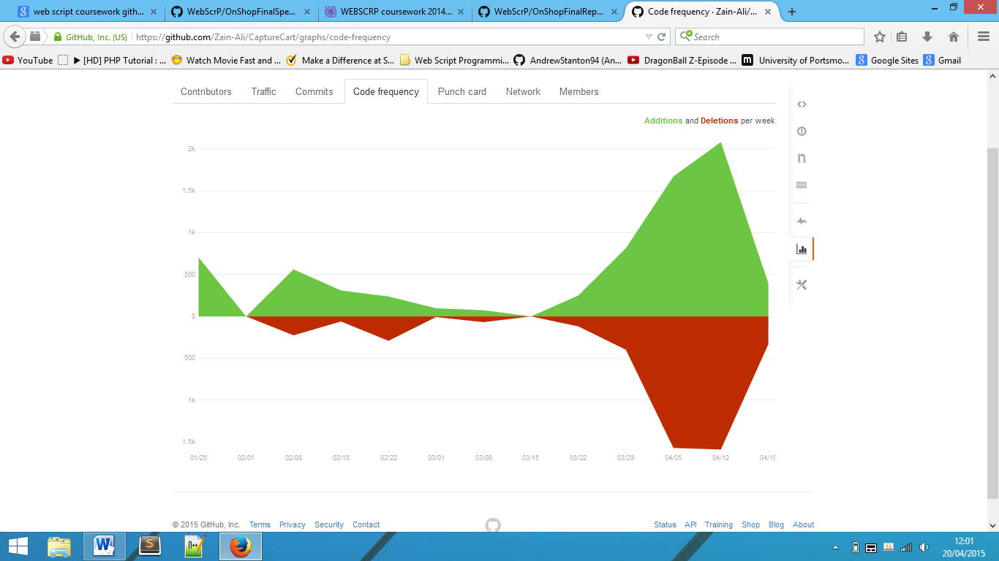I spent about 6 to 8 hours a week on this project which I feel is not enough to complete the project as sometime I missed to even capitalised 8 hours a week.

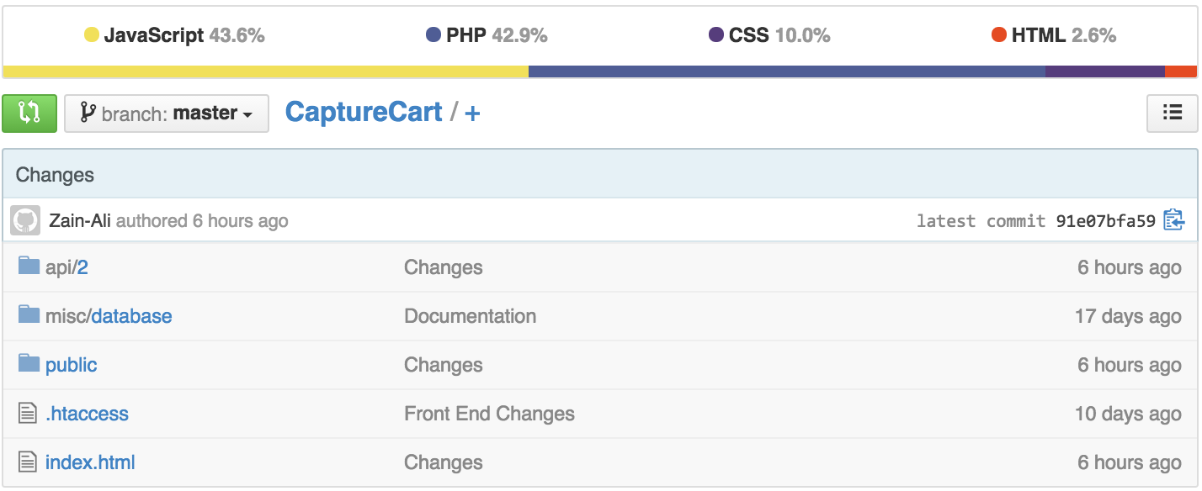Due to some technical problem with GitHub, the graph will not show my commits and overall view of project. However, this is just an overview of how my project have changed since January.

**Lessons Learned**

This project is not something which can be done 1 week before the deadline. It requires skills and knowledge which come with practice and times. Mainly, I learned that correct tools and environment is required which can be very useful for development of this particular project.

* I used Sublime Text 3, for HTML5, CSS3, JavaScript and PHP with highlights syntax errors and used for developing such tools.
* I also used Google Chrome and console which helped me to understand JavaScript errors. It was easier to write a console statement to see where the program runs and where it stops.
* I used GitHub for tracking all of the changes within the repository and also made a backup of it.
* Scheduling and time management is very important to complete a task and I should have made a schedule throughout my academic year to avoid collision between units.

**Final Gantt chart**